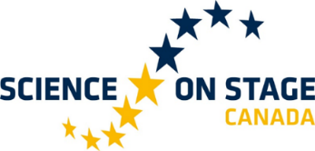
We Are All Related: Weaving In Western and Indigenous Science and Technology
Provisional schedule
For full description of activities see below
TIME | FRIDAY  August 4th 2023 | SATURDAY  August 5th 2023 | SUNDAY  August 6th 2023
8H30 |  | Light breakfast  (8h30-9h00) | Light breakfast  (8h30-9h00)
9H00 |  | Opening ceremony  “What we should know about First Peoples”  Conference by Dr. Diane Campeau, Ph.D.  On site/online  (9h00-9h30) | The Land as an Educator: Weaving Western and Indigenous Knowledge and Perspectives  Pedagogical creative workshop  (9h00-11h00)
9H30 |  | Science fair  On-site/online  (9h30-10h30)
10H00
10H30 |  | Coffee Break  (10h30-10h45)
10h45 |  | 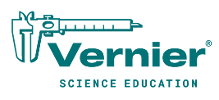  (10h45-11h45)  Engaging Students Through Exploration  of Their Environment Using Data Collection  Workshop by Judy Benton Day
11H00 |  |  | Brunch  (11h00-12h00)
11H45 |  | Lunch  (11h45-13h00)
12H00 |  |  | Science Fair  On-site/online  (12h00-13h00)
12H30
13H00 |  | Metaphorical Images of Science  Workshop by Anne Tenning  (13h00-14h00) | Conférence  « Le récit autochtone au service de la science/Indigenous Story telling Serving Science »  Dr. Diane Campeau, Ph.D.  (public)  (13h00-14h00)
13H30
14H00 |  | Science fair  On-site/online  (14h00-15h00) | Science Fair  On-site/online  Open to the public  (14h00-17h00)
14H30
15H00 |  | Coffee Break  (15h00-15h15)
15h15 |  | Walking in Balance: An Exploration of Indigenous Land-Based Pedagogy and Interconnectedness  John Harris  (15h15-18h00)
15H30
16H00
16H30
17H00 | Arrival of on-site guests |  | Closing ceremony  (17h00-17h15)
17h15
17H30 |  |  | Dismantling of stands  And Farewell snacks for participants.
18H00 | Assembly of stands  Free evening  Downtown Victoria | Break  (18h00-19h00)
18H30
19H00 |  | Gathering  Banquet  (19h00-22h00)
19H30
20H00
20H30
21H00
21H30
22H00

Science fair:
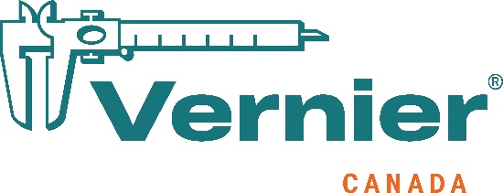
- Stands for on-site participants.
- Screens for 3’ and 15’ presentations from online participants
Workshops
- All on site educators participate in an innovative approach of applied STEM merging knowledge from the Indigenous and Western world.
The Land as an Educator: Weaving Western and Indigenous Knowledge and Perspectives Pedagogical creative workshop
- Participants will create a one of a kind weaving of the best of both worlds (on site only).

PRESENTORS
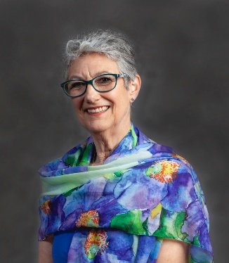
What we should know about First Peoples with Dr. Diane Campeau Ph.D. Saturday August 5th 9h-9h30

This short talk seeks to give an overall idea of the indigenous communities in Canada. Participants will be able to grasp the general concepts links to the First Nations.

Dr. Campeau obtained a doctorate degree in education at the Sherbrooke University. Her work mainly focuses on first nations pedagogy. She also obtained a diploma in education in regard to environment.

Engaging Students Through Exploration of Their Environment Using Data Collection with Judy Benton Day and Hareem Achmed Saturday August 5th 10h45-11h45
Students of all ages become more engaged in the learning process when they can see how it may affect their world. As we learn more about the changes in our environment, it becomes more important for students to understand how these changes occur and how to monitor them. This workshop will explore how students can use various Vernier Education sensors to monitor water and soil quality. Activities will discuss possible causes of the changes and the effects on plant and animal life from western and indigenous perspectives.
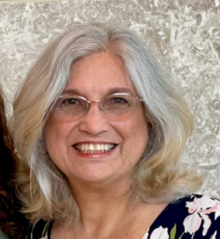

Judy Benton Day is a science education consultant who specializes in science technology and student research training. Judy is a former high school teacher of biology and marine ecology. Judy left the classroom to join The Science House at NC State University for 14 years assisting teachers with incorporating the use of technology into their curriculum and giving teacher workshops across North Carolina. Judy is a National Instructor with Texas Instruments Teachers Teaching with Technology and a consultant for Vernier Software and Technology. In addition, Judy has served as the state director for the NC Science and Engineering Fair since 2003.

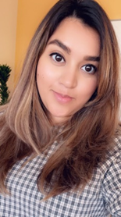

Hareem Ahmed is an accomplished Operations Manager with a strong passion for science education. With a background in operations management and a deep commitment to empowering science teachers. Hareem combines her expertise to optimize educational resources and support effective teaching strategies. She has been under the Vernier umbrella for the last 9 years. She is an advocate for hands-on learning experiences and stays abreast of the latest scientific discoveries in both western and indigenous communities. Through her unwavering commitment to advancing science education, Hareem makes a meaningful impact in nurturing scientific curiosity in students and empowering educators through Vernier Science Education.

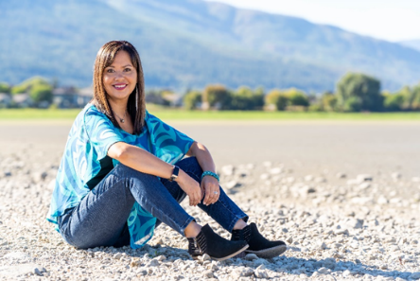
Metaphorical Images of Science with Anne Tenning. August 5th 13h-14h

This workshop will explore the perceptions and lived experiences of Indigenous learners in science education. What has changed in recent years in the way that science is taught and what work still needs to happen? What is a metaphor interview and how can this technique be utilized in our work as educators?

Anne Tenning is a member of the Stz'uminus First Nation on Vancouver Island. Anne worked as an educator in the B.C. K-12 education system for 23 years as a secondary teacher, a District Principal of Indigenous Education, and most recently as the Senior Manager of Curriculum with FNESC. Anne is now consulting and focusing on her writing with a children’s book and a memoir in the works. Anne's mother, Elizabeth Tenning, attended Kuper Island Residential School and Anne considers her mother to be her greatest influence and role model. In 2008, Anne received the Governor General's Award for Excellence in Teaching Canadian History. She currently lives on the beautiful, ancestral, and unceded territories of the Secwepemc people in Salmon Arm, BC.

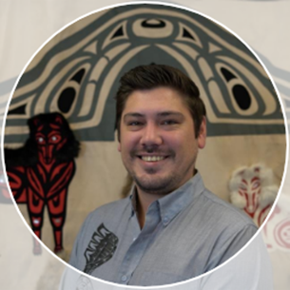
Walking in Balance: An Exploration of Indigenous Land-Based Pedagogy and Interconnectedness with John Harris August 5th 15h15-18h
This workshop will focus on the interconnectedness of life around the Salish Sea and our human dependence upon healthy eco-systems. Participants will be introduced to a variety of Indigenous pedagogical approaches including land and water-based, seasonal, storytelling, and relationality through an examination of local ecology and food systems. It will further explore the role of Indigenous knowledge and knowledge holders, Elders, and educators in maintaining these fragile yet resilient systems.
John Harris is an Indigenous Educator and member of Snuneymuxw (Nanaimo) First Nation. Having had the privilege of living, learning and working as a Coast Salish person in Lekwungen (Greater Victoria) territory his entire life, many of his cultural teachings are rooted in this place, and on the land. From roasting salmon over open fires at Esquimalt Lagoon and harvesting Dungeness and Red Rock crab in the estuary below Royal Roads University, to learning to process deer and hunting grouse in the T’Sou-ke (Sooke) foothills, his life has been enriched by a deep and personal connection to the land. As an educator, John has found that incredibly profound learning occurs at the intersection between traditional ecological knowledge of local First Peoples, land-based experiential teaching, and an openness on the part of educator and student alike to embrace Uy’skwuluwun (a good mind and a good heart) when doing this work. His work in this field has culminated in his presenting to educators around the world about ‘why’ it’s important to engage learners in this way. While this type of learning can be both impactful and life-long, it’s also interdisciplinary making it relevant to educators of all backgrounds.
Huy ch q‛u Siem
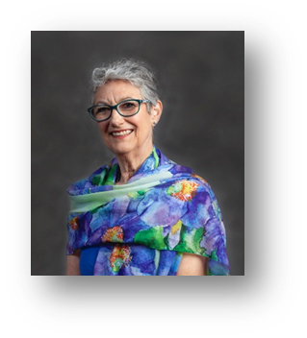
Le récit autochtone au service de la Science/Indigenous Story telling Serving Science with Dr. Diane Campeau, Ph.D. August 6th 13h-14h
Les récits des Premiers Peuples transmis depuis des milliers d’années contiennent la plupart du temps des informations scientifiques importantes. Cette présentation illustre à travers des récits de plusieurs nations différentes à travers le pays, des notions de sciences qu’il est possible de travailler avec les élèves du primaire et du secondaire en lien avec le curriculum scolaire et d’ainsi rendre justice aux savoirs autochtones.

