Description of the activity : HAPPY FEET
3-5 y.o./6-8 y.o.
Pedagogical intent:
- Explain that odors Expliquer que les odeurs et d’autres sens peuvent servir à l’identification de substances
Duration : Preparation : 20’; Activity : 1st part : 20’; 2nd part: 12’
Materiel
For the preparation | 1^{1st} part | 2e partie (listes ci-dessous)
- Cotton  - Small closable containers*  - Glue (eg. : crazy glue)  - Different perfumes or Eau de toilette  - Un-erasable pen | - Pinguoin puppet  - Prepared small closable containers | - Singing birds (eg. : Audubon stuffed birds)  - Small plastic animals with their progeny
*The number of containers will depend on the number of participants.
Step | Description | Duration | Materiel
En préparation pour l’activité**
1 | Glue a piece of cotton at the bottom of each small container and on the inside of each cover. | 20’*** | Cotton  Small closable containers  Glue (eg. : crazy glue)
2 | For each couple container/cover, deposit on the cotton a few drops of the perfume. Immediately close the container. |  | Different perfumes
3 | Identify each container with its cover using a code.  Note :  - So that participants associate odors and not a symbole, we suggest to write different names both on the covers and containers and on a list.. |  | Un-erasable pen
1st part
1 | Q.How do Happy Feet and friends find their parents among hundreds of them? | 2’ | Pinguoin puppet
3 | Give to each child and parent either a container or a cover.  Note:  - Make sure that every container has its cover. |  | Contenants parfumés
4 | Ask the participants to seek out the parent/child. | 10’
5 | Once all participants have found eachother, ask them how they di dit. | 3’
6 | Q. : Where can we apply odor recognition? (dangerous substances, food, fire, etc.) | 5’
*The number of containers will depend on the number of participants.
**Once prepared, these containers are reusable. Keep them tightly shut to keep the odors.
***Duration varies according to the number of containers to prepare.

2nd part
1 | Q. How do parents and children of other animals recognize eachother? | 2’
2 | Present one by one the stuff birds so that everyone hears their chant. Ask them if there are such birds in their surroundings.  Note:  - Let the children play a few minutes with the birds and encourage exchanging | 5’ | Singing birds (eg. : Audubon stuffed birds)
3 | Present one by one the plastic animals with their progeny.  Ask the children how these animals recognize their parents.  Are there any in their environment? | 5’ | Small plastic animals with their progeny

Singing birds
- Red-winged blackbird
- Wood-pecker
- Canada goose
- Blue geai
Small plastic animals with their progeny
- Zebra
- Elephant
- Lion
- Cat
- Dog
- Crocodile
- Monkey
- Girafe
- Chicken
- Whale (if available)

HAPPY FEET ET SES AMIS RECHERCHENT
LEUR MAMAN

Happy Feet et ses amis ont joué toute la journée dans la neige.

Ils doivent maintenant retourner à leurs parents.

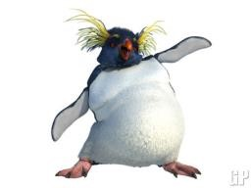
Mais voilà, toute la colonie est réunie pour fêter l’anniversaire de Lovelace et il leur faut retrouver leurs parents parmi des pingouins qui se ressemblent tous.
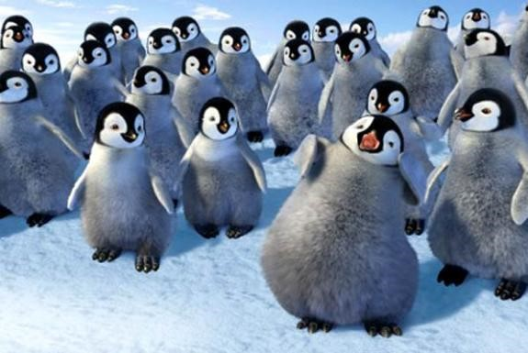
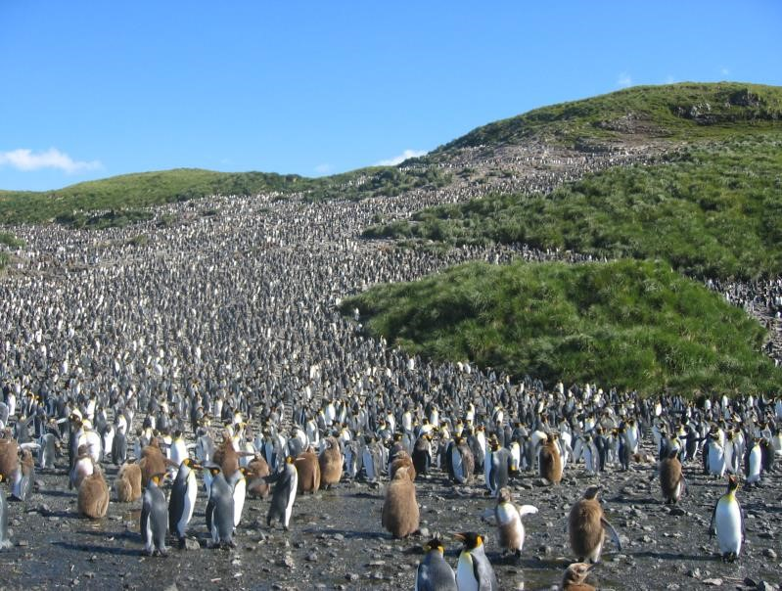
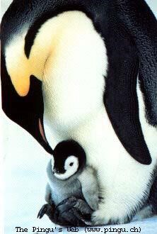
Aide Happy Feet et ses copains à retrouver leur parent.

